**[A] 02/25/2016**

**Alan Groff**



Structural Design

(Inside View)

**Vertical corrugation**

Design#:

**160194-01_A**

589*/*16

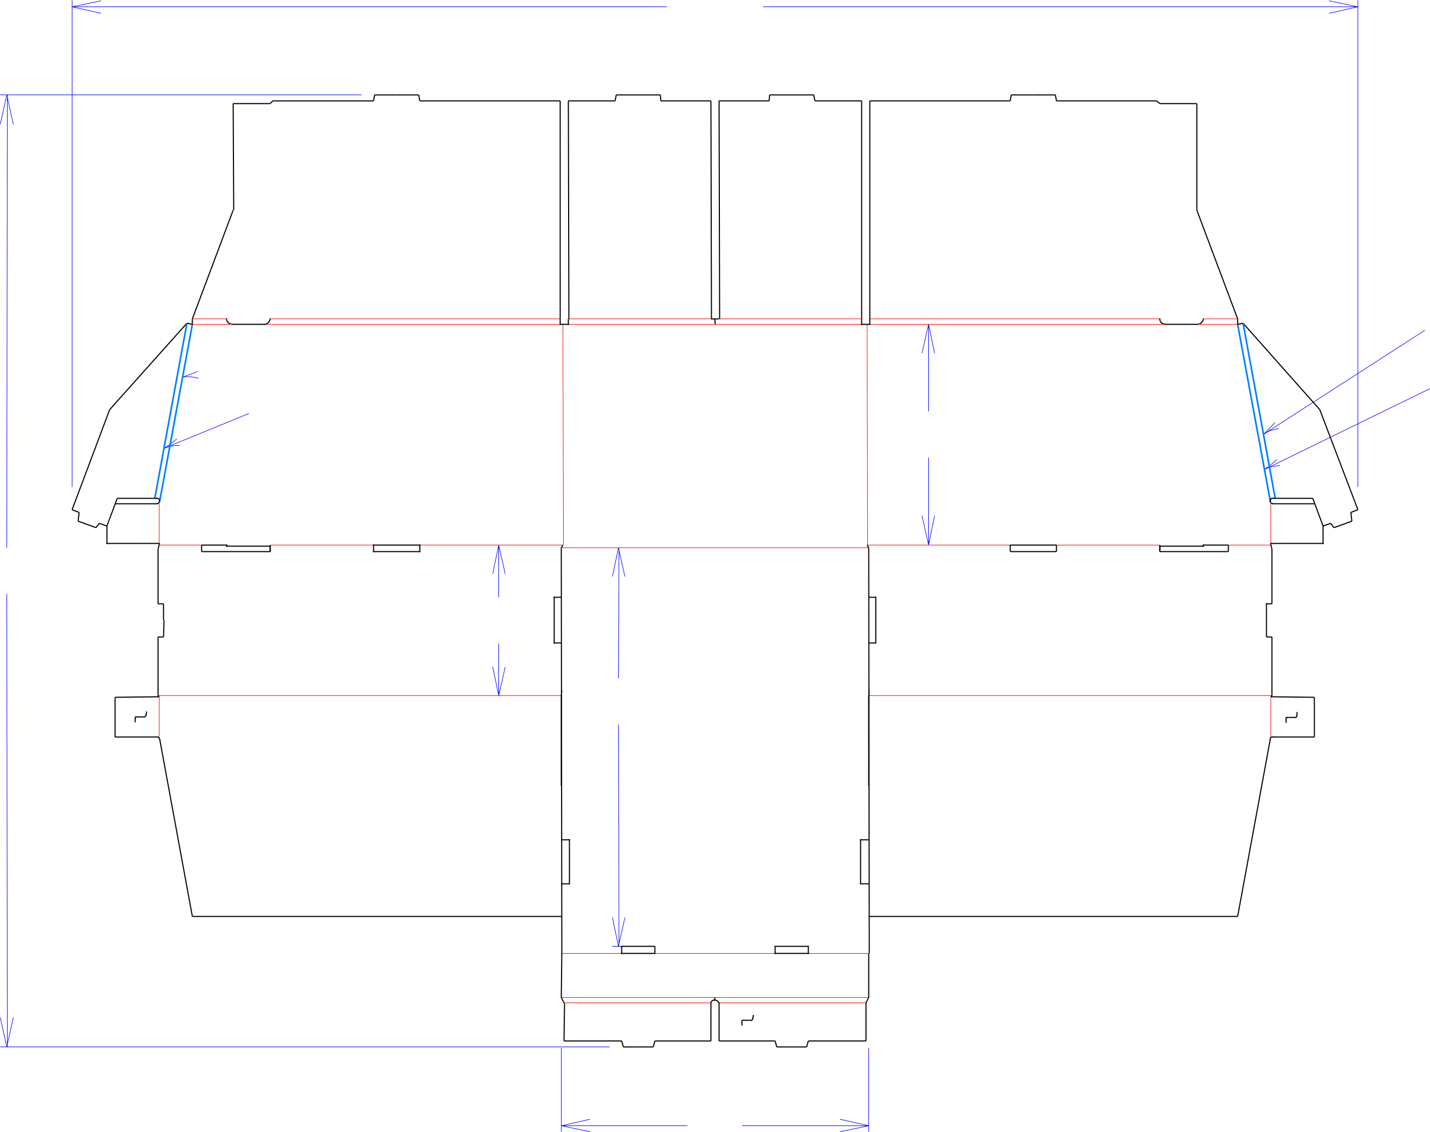

 1/4 1/4 perf in channel

1/4 1/4 perf in channel

101*/*16

 137*/*8 

433*/*8

67*/*8

183*/*16

1/4 1/4 perf in channel

1/4 1/4 perf in channel

Customer:

**DeMet's Candy**

Description:

**Turtles 10pk BJs tray (stacking)**

**SINGLE-OUT DRAWING**

Qty/Unit:

Style: **NJDC**

Board: **32BK**

Combination: **35HP - 23M - 35HP**

I.D. : **13+3/4 x 18+1/8 x 10**

Area of Blank - Waste : **13.35 sq. ft.**

Waste on Blank : **24.34%**

Finished Piece Weight: **1.38 lbs./626.94g**

Over-all Blank: **433/8 x 585/8**

Notes:

14



Cut Crease Crease with Matrix Cut Crease Half Knife Cut Tear Tape Perforation



Revision Info:

**fit prod**

Designer:

Designright and Copyright of DS Smith Corrugated Packaging Ltd. This technical Specification is subject to Manufacturing tolerances. Drawing dimensions shown are crease to crease. Date printed: 08/13/2018